Online CCA Registration
USER GUIDE for
STUDENTS

Table of Contents

Login 1
CCA Registration 3
Information Needed 4
Choices 5
Print Confirmation Slip 7
Sample Confirmation Slip 8

Login
URL: https://acsj.schoolhub.sg/

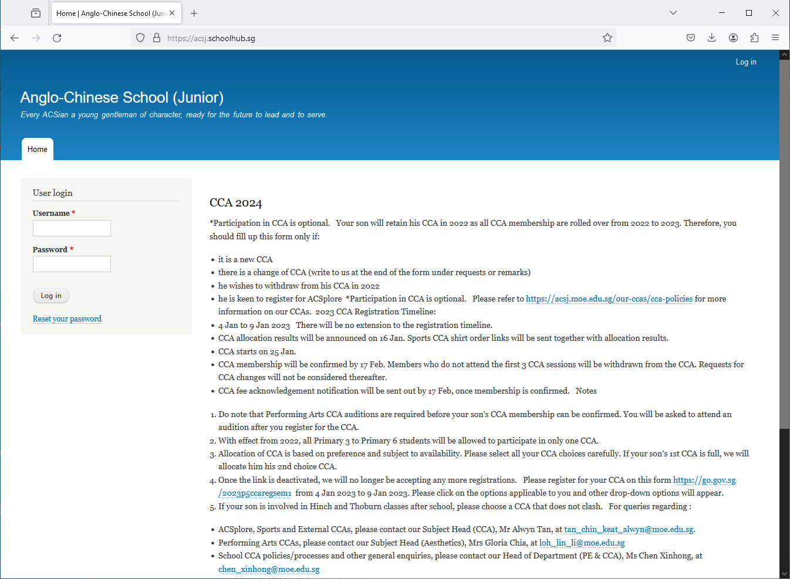

Steps
- Enter Username
- Enter Password
- Click Log in button

Upon successful login, you will be able to see the CCA Registration link under Pupil Menu.

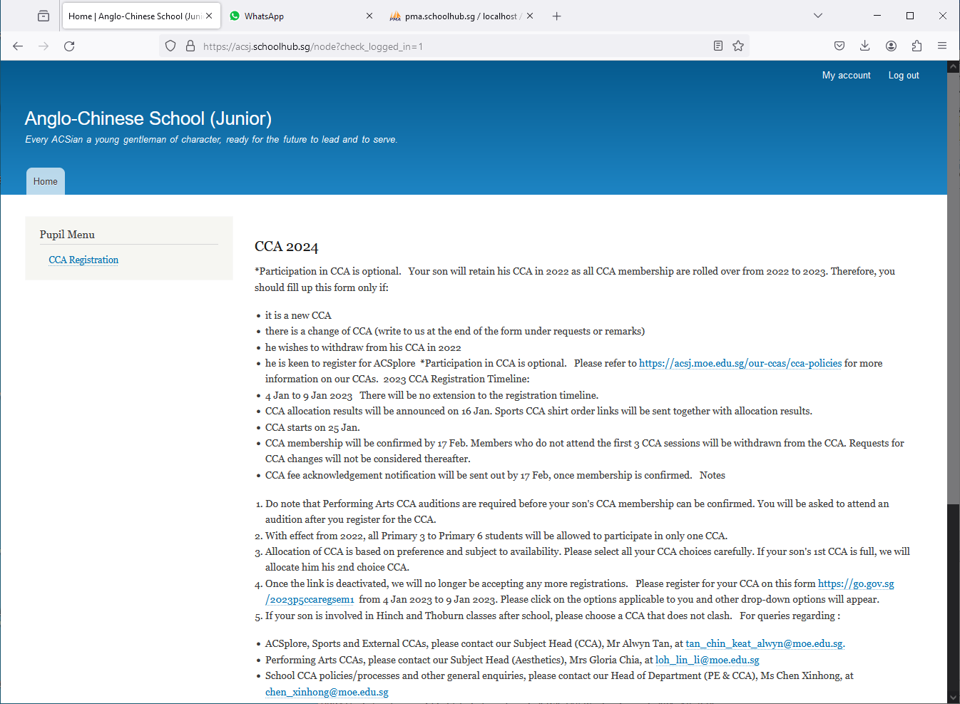
CCA Registration
Read the Announcements

Steps
- Click on CCA Registration button to begin

CCA Registration
If you have not registered, you will see this message: “You have not submitted yet”.

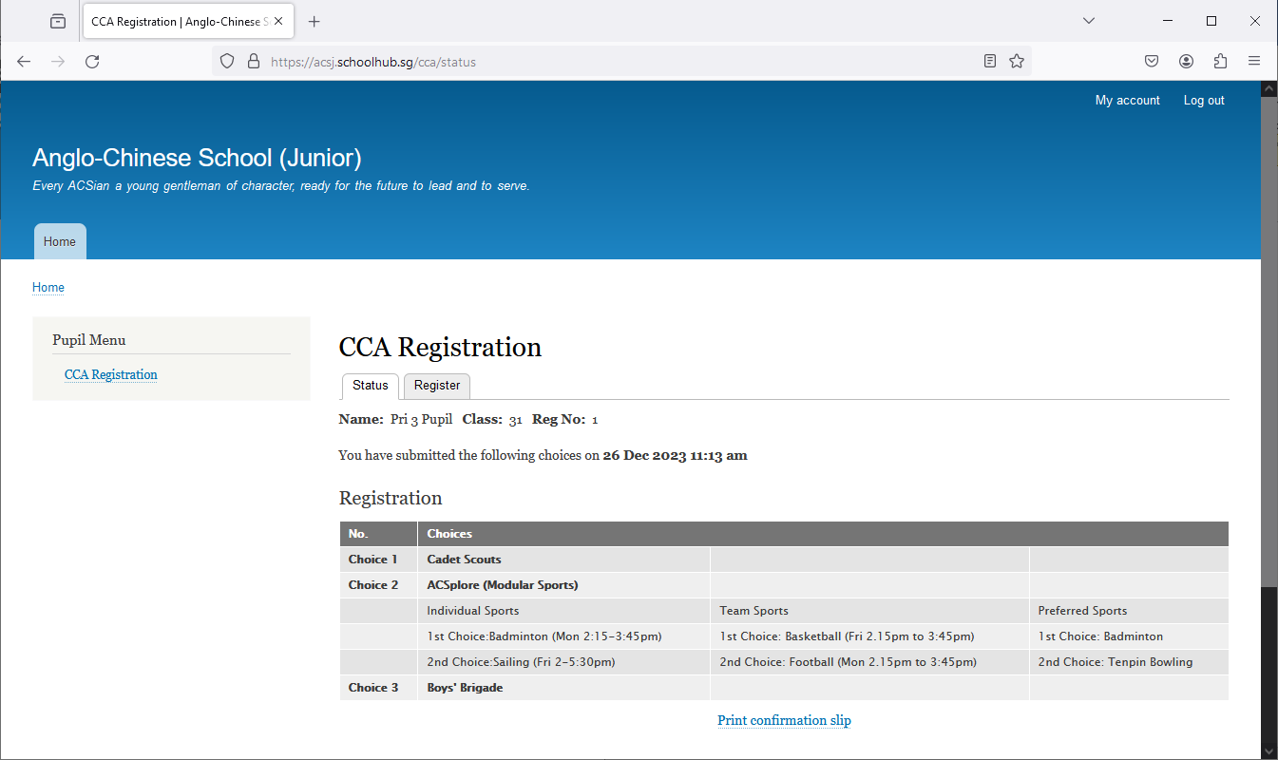
Click Register to begin

Steps
- Click on Register tab to begin

Information Needed
- Choices (Your choice of preference)
  - 1st choice
  - 2nd choice
  - 3rd choice
- If you choose Uniform Group, Performing Arts or Clubs and Societies
  - No further action needed
- If you choose ACSplore (Modular Sports)
  - Individual Sports
    - Individual Sports 1st Choice
    - Individual Sports 2nd Choice
  - Team Sports
    - Team Sports 1st Choice
    - Team Sports 2nd Choice
  - Training Squad (Optional)
    - 1st Preferred Sport
    - 2nd Preferred Sport
- Request or Remark

Choices
You shall indicate your choice of preference with Choice No 1 as your most preferred choice, follow by Choice No 2, Choice No 3 etc

Steps
- Fill in all your choices

e.g. 1st Choice
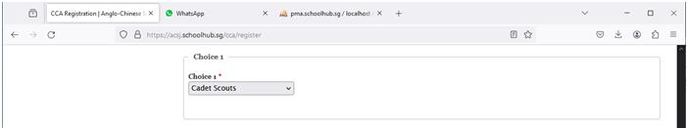

e.g. 2nd Choice
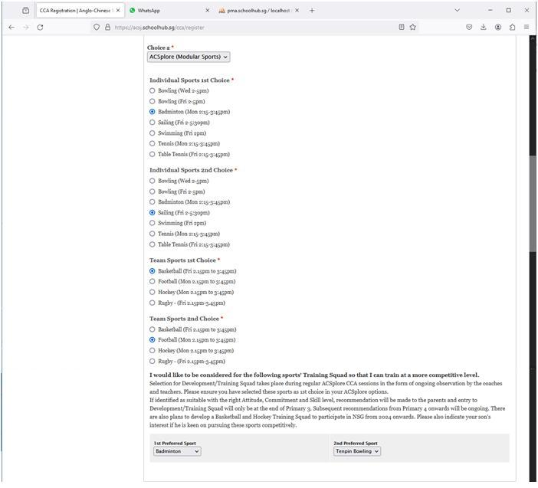

e.g. 3rd Choice

Remark
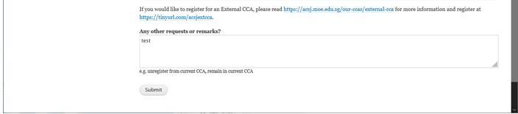
Click Submit to complete the registration

Steps
- Fill up all the information, if available
- Click Submit button

Note:
You may Re-Submit if you decide to change your choices (Until the closing Date)

Print Confirmation Slip

Click Print Confirmation Slip

Note
You may print a copy of the Confirmation Slip for your own reference.

Sample Confirmation Slip

