Online CCA Registration
USER GUIDE for
P4/P5 STUDENTS

Table of Contents

Login 1
CCA Registration 2
Print Confirmation Slip 4
Sample Confirmation Slip 5
Check CCA Allocation 6
Sample CCA Allocation Slip 7

Login
URL: https://acsj.schoolhub.sg/

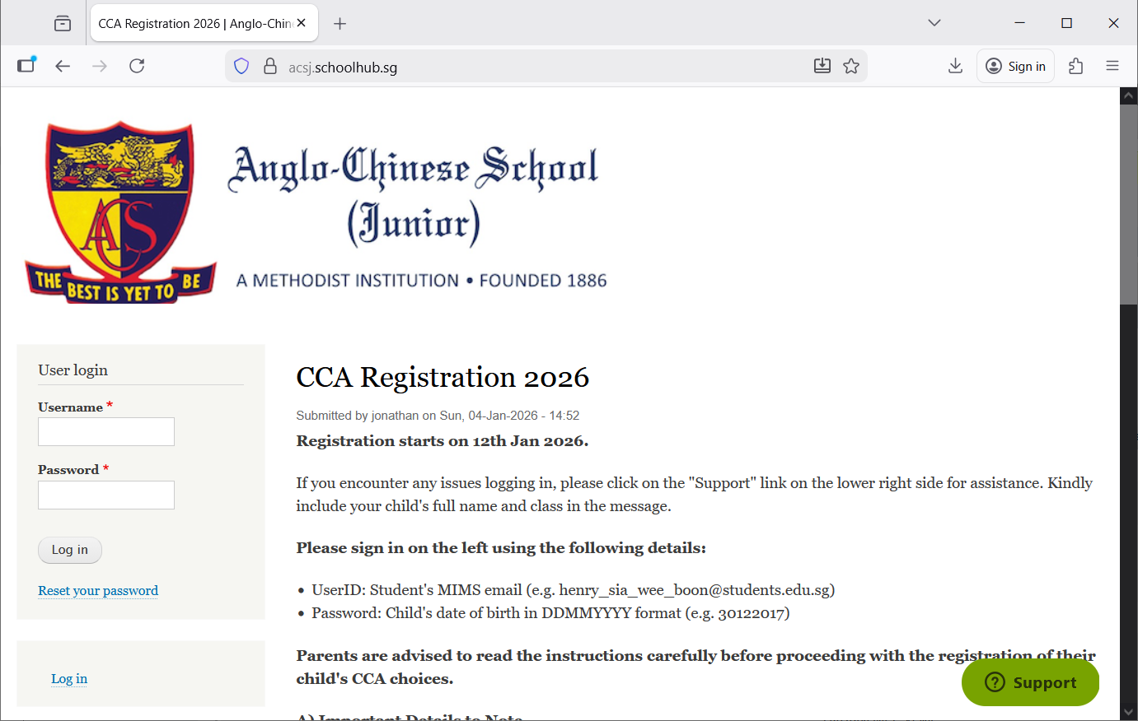
Please read the announcements.

Steps
- Enter your username.
Click “Support” if you need any assistance.
- Enter your password.
- Click the Log in button

CCA Registration
Upon successful login, you will be able to see the CCA Registration link under the Pupil Menu.
If you have not submitted your registration, the following message will be displayed: “You have not submitted yet”.

Steps
- Click on “CCA Registration”.
- Click on “Register” to begin.
- Read the pre-registration instructions.
2. Click ‘Register’ to begin
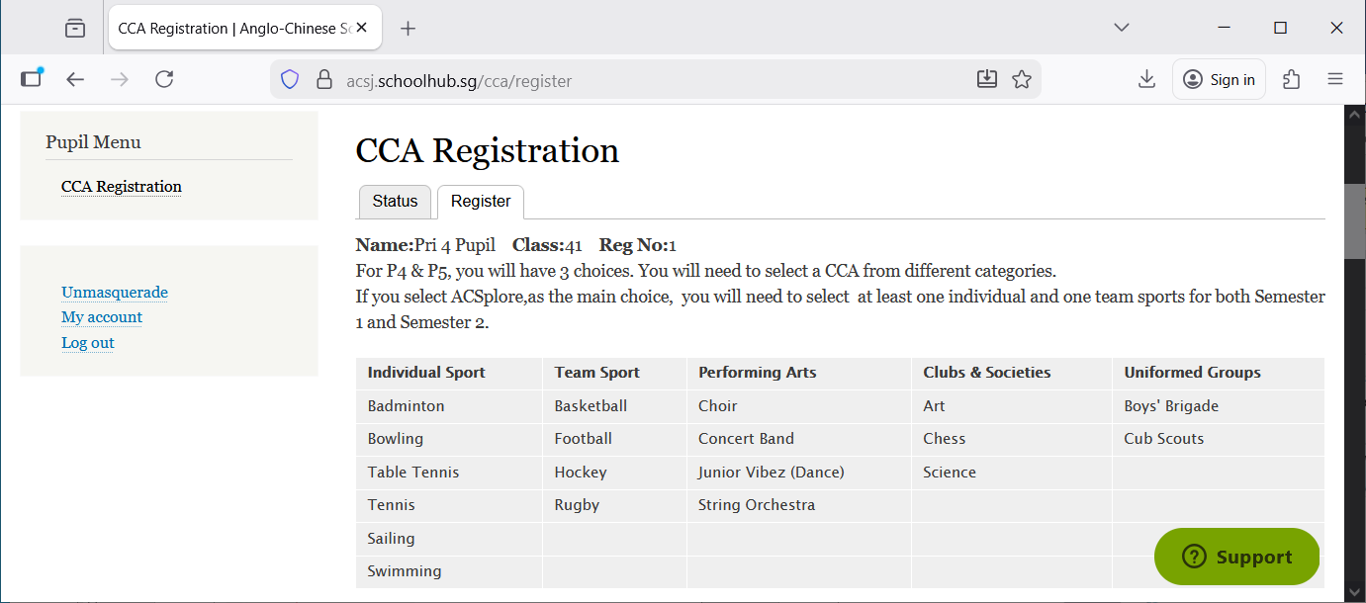
3. Please read the pre-registration instructions.

- CCA Registration

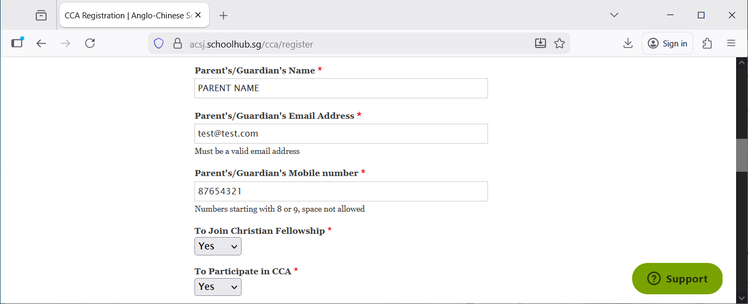
Please indicate if you are interested in joining the Christian Fellowship.
(The outcome will be communicated separately by the Christian Ministry staff overseeing the CCA.)

Please indicate whether you are interested in participating in a CCA.
If yes, please proceed to the next page to enter your CCA choices.

Select CCAs for each semester.
- Fill all choices: Every choice slot on the website must be completed.

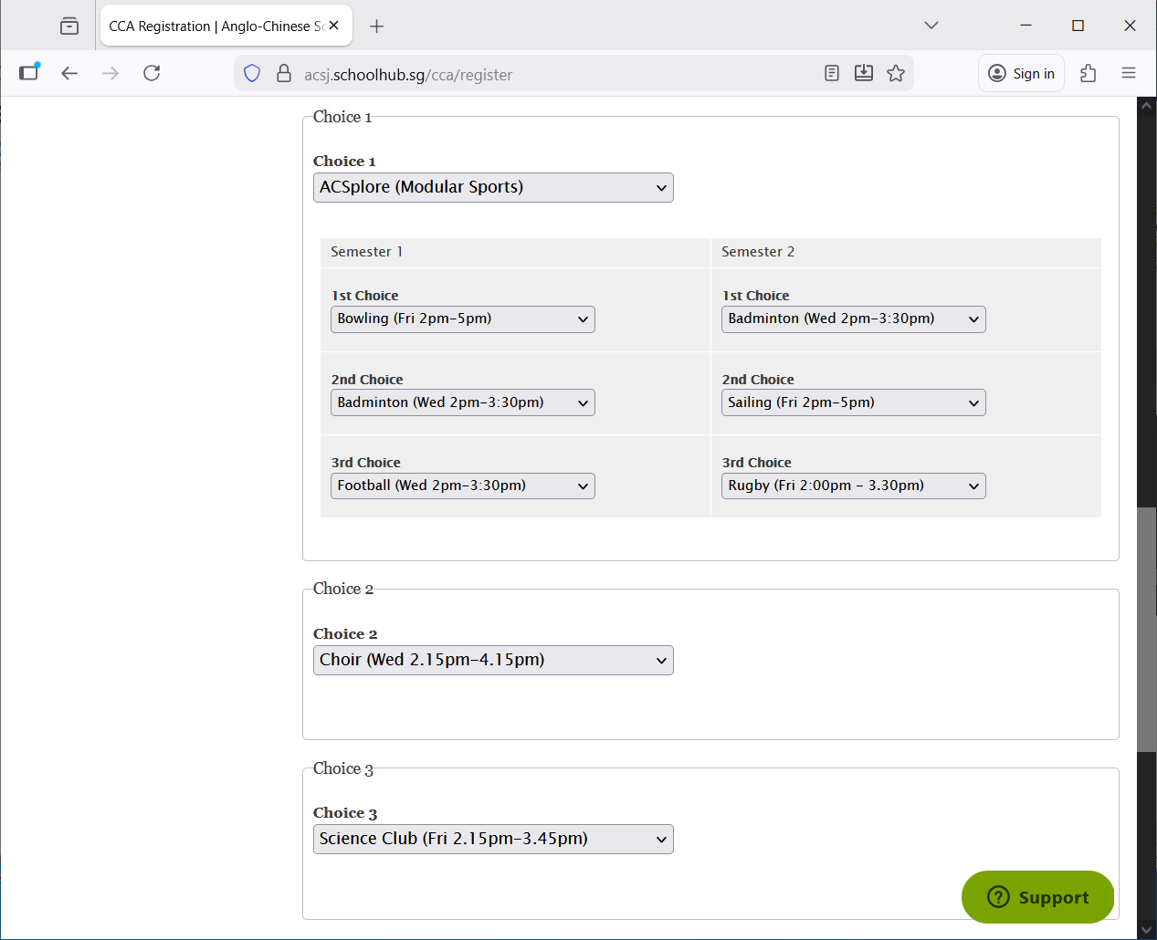
Please key in your remarks, if any.

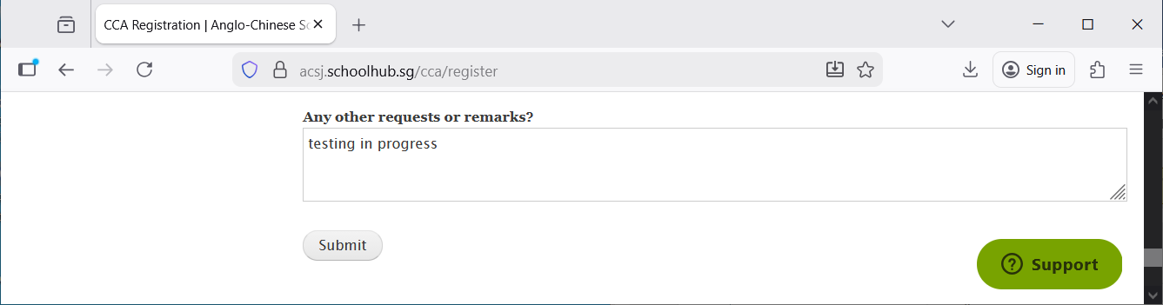

Steps
- Update all the information
- Click Submit button

Note: You may re-submit your registration (overwrite your choices) before the closing date.

Print Confirmation Slip
Once you click “Submit”, you will be redirected to the Status Tab, where your choices will be displayed.
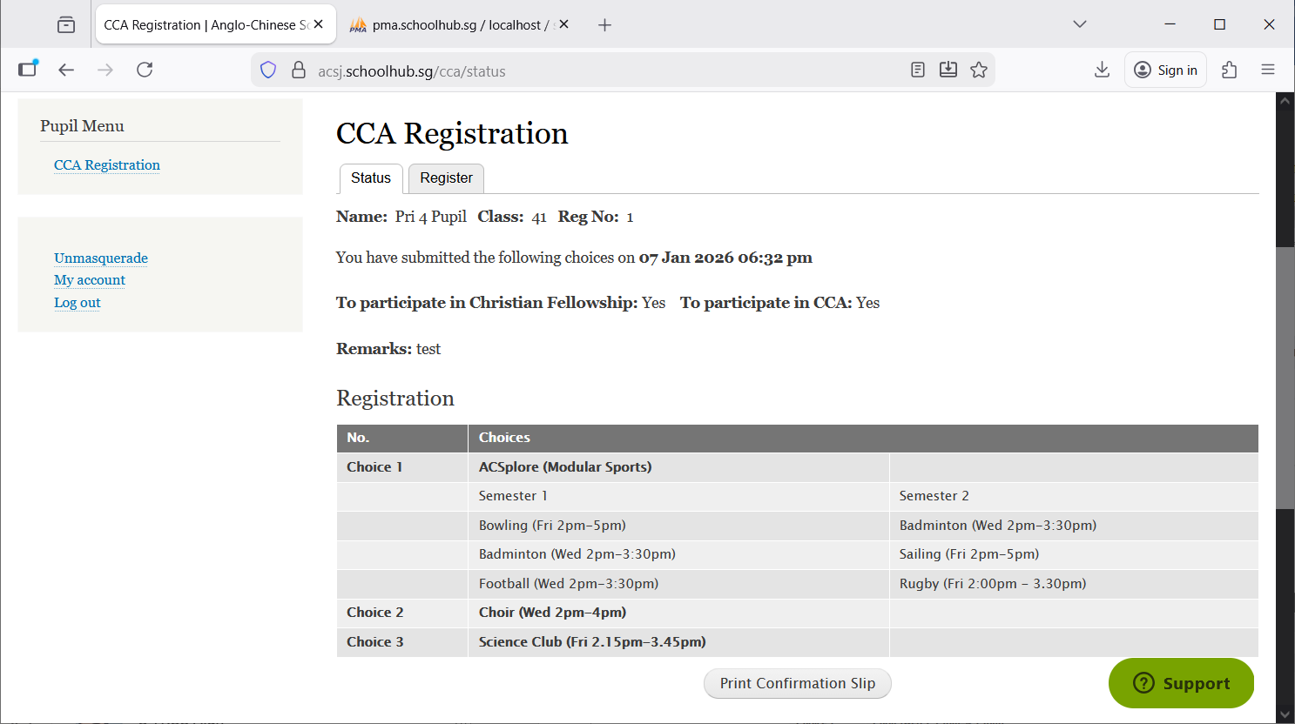
Print CCA Confirmation Slip
Steps
- Click the Print Confirmation Slip button to save a PDF copy of your submission.

Sample Confirmation Slip
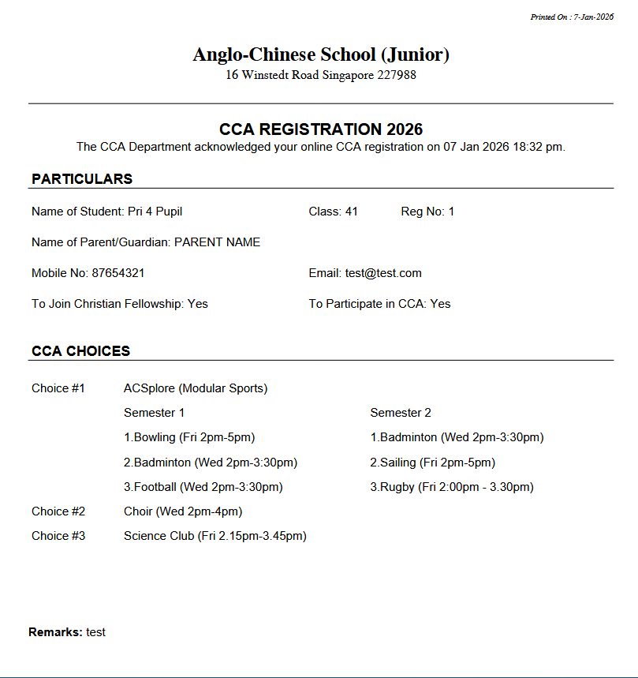

Check CCA Allocation
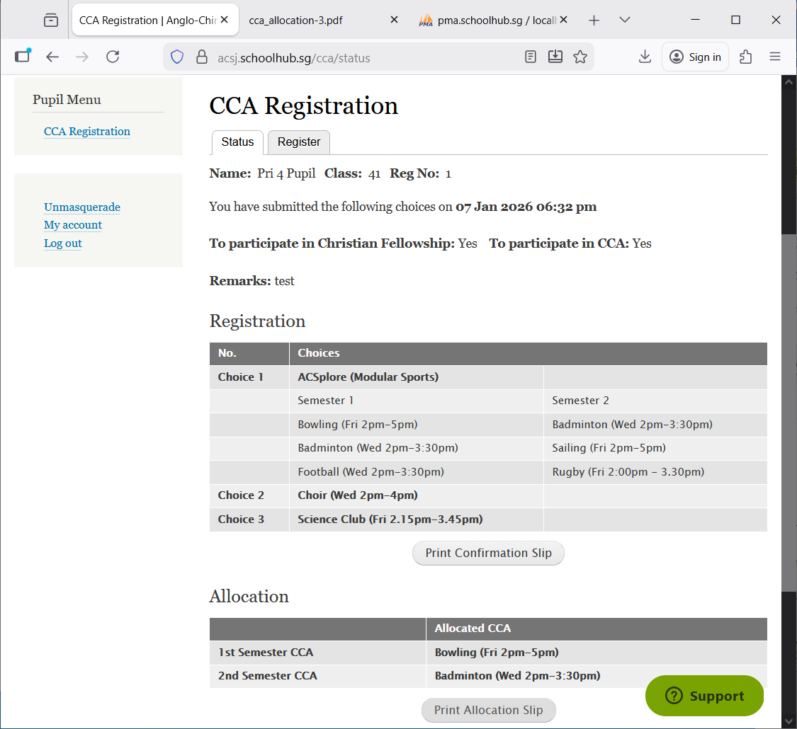
Allocated CCAs.
Print CCA Allocation Slip.

Sample CCA Allocation Slip

